**INTRODUCTION**

The focus of this requirement specification is the Edinburgh branch of a Scottish care charity that provides several ranges of services to people who are vulnerable across the city. Clients have limited access to shops, hence the charity organization improvised by taking on volunteers to help with home deliveries of groceries and medical supplies where necessary. The current system used is spreadsheet and manually assigning clients to volunteers by the administrators. The aim is to develop a minimum viable product that eliminates the spreadsheet system and automates the processes of the organization hence achieving scalability and expansion of the organization.

**1.0 OVERVIEW AND CRITICAL EVALUATION OF THE CURRENT SYSTEM**

**1.1 Overview of The Current System**

The current coverage of the deliveries are only postcodes within the City of Edinburgh boundary, serviced by 30 volunteers. The charity organization is therefore currently recruiting new volunteers to expend the coverage. This is based on the assumption that there are no challenges with misplaced deliveries or damages incurred by any of the existing crop of volunteers.

The deliveries are consolidated in a way that volunteers can collect items from multiple shops as well as pharmacy for the clients, which eliminates multiple deliveries to a client. Orders from the clients are received by two means, through telephone and via email. The telephone orders are from clients without internet access.

When a new volunteer is signed up into the new system, they are required to provide the following details to the administrator:

* Volunteer Name
* Volunteer address,
* Email address
* Bank details (this is to reimburse for cost incurred on purchases for the client),
* Registration number of the car the volunteer will use
* The available days the volunteer can work
* The PDF copy of insurance certificate of the car to be used

The administrator records all the details of the volunteer in a spreadsheet this includes the expiry date of the car insurance of the volunteer on the spreadsheet. New volunteers also have to undergo a PVG (criminal record) background check. The date of approval of this criminal check is also recorded on spreadsheet and a copy of such approval is recorded in a folder.

When a new client is onboarded into the system their details are recorded in another spreadsheet and noting if they have internet access or not.

In a scenario when a client is in the system and request for a grocery delivery, the administrator records delivery requests in another spreadsheet.

The client has to provide:

* The date they prefer the items to be delivered
* The name of the shops they wish the items to be bought (this is limited to 3 shops)
* The list of items to be bought from each selected shop
* If they need medical supplies (This will require the volunteer to first go to the client house first to get the prescription)

The order manually matched to an available volunteer close to the client based on the administrator’s knowledge of the area. The administrator contacts the volunteers close to this client to know their availability to fulfil this delivery.

Reconciling a completed delivery is another scenario, this involves the volunteer sending a screenshot of the receipt(s) for the groceries purchased to the administrator. The administrator then records these amounts in the delivery’s spreadsheet. The volunteer is then reimbursed the amount spent into their bank account.

The money for each service is collected from clients monthly at the client’s location and at a pre-arranged time. These is stored in the client spreadsheet.

So far, the system currently has 3 spreadsheets for storing information

* Volunteer spreadsheet
* Client spreadsheet
* Delivery’s Spreadsheet

The system utilizes different folders on the administrator’s local pc to store PDFs of certificates and Scans of receipts.

**1.2 Weaknesses and Limitations of The Current System**

* Some clients do not have internet access so receiving orders via telephone is a major limitation.
* All information of both the client and volunteers are recorded on a spreadsheet and kept by the administrator this a major weakness of the current system.
* The administrator has to manually match a client’s location to a volunteer

**1.3 Implication of Weaknesses and Limitations of the Current System**

Receiving orders via telephone greatly limits how robust the proposed system can be developed into an automated system that lessens the manual inputting of orders by the administrator.

The implication of keeping all information in spreadsheet is that the information is not secure as vital personal information of clients and personnel can be assessed by anyone that gain access to the computer used by the administrator, this information is sensitive and utmost level of security must be observed. Also, vital information kept on spreadsheet can be lost once the computer system develops a virus or files are deleted by error.

The implication of manually matching orders of client’s location to the nearest volunteer is that efficiency of order matching will be really low. The administrator might not be familiar with all locations and might not effectively match a client to his nearest volunteer in a way a computer system with a map functionality will help.

**1.4 Opportunities for Improvement on The Current System**

The opportunities for improvement on the current system are as follows:

* **Success of the deliveries:** The success of the delivery scheme has built trust among clients and should be improved by using appropriate systems.
* **Existing spreadsheet records**: The opportunity provided by this spreadsheet method of storage is that it gives a blueprint for proper database design of the proposed system and saves time to focus on the development of the entire system.

**2.0 REQUIREMENT DEFINITION**

**2.1 Overview Description of the Proposed System**

The current system will be replaced by an application software that addresses the needs of the organization, this proposed system guarantees scalability and stability for the charity organization.

The proposed system will have the following windows:

* **Delivery**: This will be window that contains a map that shows location of each client and volunteers with proximity to such client. This will help administrators assigned orders to the closest volunteer after calling to confirm their availability.
* **Orders**: The clients with internet access will be given access to this window via a link to input their orders and submit. The administrator can also input the orders that a client without internet access place via telephone.
* **Feedback**: The clients with internet access will be able to leave feedback after delivery so the charity organization can use these feedbacks to better improve on certain aspects of the operation. The clients without internet access can drop feedbacks via telephone which will be inputted by the administrators
* **Registration:** This will be a window to register new clients and volunteers. This will help input the details of either a new client or a new volunteer.
* **Reports:** This will show the reports that the manager will present during quarterly meeting with the Board of Trustees. The reports will be a dashboard showing; number of volunteers, records about the volunteer’s car insurance, PVG, number of clients, average deliveries per week and average distance between client and volunteers.
* **Payment and reconciliation:** This window will help document and track pending payments to reimburse a volunteer after he/she has sent proof of a completed delivery.

The system will store the information such as: Client information, volunteer information, delivery report, order report, payments and reconciliation in a database which will be categorized in tables. This will help populate the report window with adequate data to track number of volunteers in the system, number of clients etc.

**2.2 Function Requirements and Non-Functional Requirements**

|  |  |  |
| --- | --- | --- |
| **S/N** | **Functional Requirements** | **MoSCoW** |
| **1** | Automate matching clients to volunteers by administrator for delivery | Must have |
| **2** | Provide a map to show list of post code where clients and volunteers are located. Should be displayed on a map | Should have |
| **3** | Collect feedbacks from client | Can have |
| **4** | Accept orders via telephone from clients | Must have |
| **5** | Input details of clients and volunteers on spreadsheet | Won’t have |
| **6** | System should accept high quality scans of PVG and receipts | Can have |

**Table 1.0**: A tables showing functional requirements of proposed groceries delivery system with appropriate prioritization

|  |  |  |
| --- | --- | --- |
| **S/N** | **Non-Functional Requirements** | **MoSCoW** |
| **1** | System must be secure | Must have |
| **2** | System must follow appropriate rules in protecting the data of the organization | Should have |
| **3** | The user experience should be favourable to use | Should have |
| **4** | System should work with more than one administrator | Won’t have |
| **5** | Scans of the PVG and receipts should be high quality | Can have |

**Table 2.0**: A table showing non-functional requirement of the proposed groceries delivery system with appropriate prioritization

**3.0 HIGH LEVEL USE CASE DIAGRAM AND USE CASE DESCRIPTION**

**3.1 Use Case Diagram**

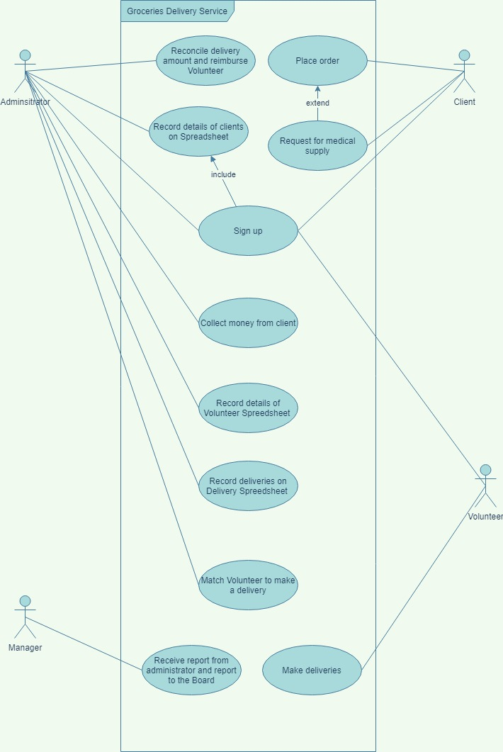

**Figure 1: High level use case diagram of the current system**

**3.2 Use Case Description for top priority requirement requested by manager**

**Use Case:** Match client to volunteers

**Pre-conditions:** “Place order” must have been executed

**Actors:** Administrator, clients

**Goal:** To automate the process of matching clients to a subset of volunteers

**Overview:**

When a client places an order through either the online ordering system or through the telephone. The administrator can see a list of volunteers that is closest to the client on a map based on their addresses, the administrator can then easily check with the subset of volunteers to confirm their availability. Once the administrator is certain of an available volunteer, he/she can then assign the available volunteer to deliver the order of the client.

**Cross reference:**

To help the administrators to match clients to volunteers for arranging deliveries. This should be based on their current way of doing it but automating the matching to give a subset of potential volunteers for them to view and getting rid of the spreadsheets.

**Typical course of events**

|  |  |
| --- | --- |
| **Actor action** | **System response** |
| 1. The client specifies the groceries they need |  |
| 1. The Administrator inputs the order into system | 1. The system shows a map of volunteers close to the client |
| 1. The administrator confirms from the subset of volunteer if they are available |  |
| 1. The administrator matches the available volunteer to deliver the client’s order. | 1. The system records the volunteer that’s meant to fulfil the order |

**Table 3.0: A table showing typical course of events in the system**

**Alternative courses**

|  |  |
| --- | --- |
| **Actor action** | **System response** |
| 1. Client inputs the list of items they need and the specified store to get the item | 1. The system accepts the request and displays the closest volunteers to the client |

**Table 4.0: A table showing alternative course of events in the system**

**Actor description:** According to a student guide to object-oriented development, an actor description briefly describes the actor in terms of the role and job title.

* **The administrator**: uses the system to match orders of clients to the various available volunteers closest to the client. The administrator is able to see the closest volunteers on a map. The administrator also has to input the orders of the client who do not have internet access into the system for the system to generate a match.
* **Volunteers:** The volunteers help the clients go to shops or pharmacy to buy groceries or medication.
* **Manager:** The manager collects the report of the overall business and relate it to board of trustees
* **Client:** These are individuals who require help with purchase of groceries and medication.

**4.0 ACTIVITY DIAGRAM**

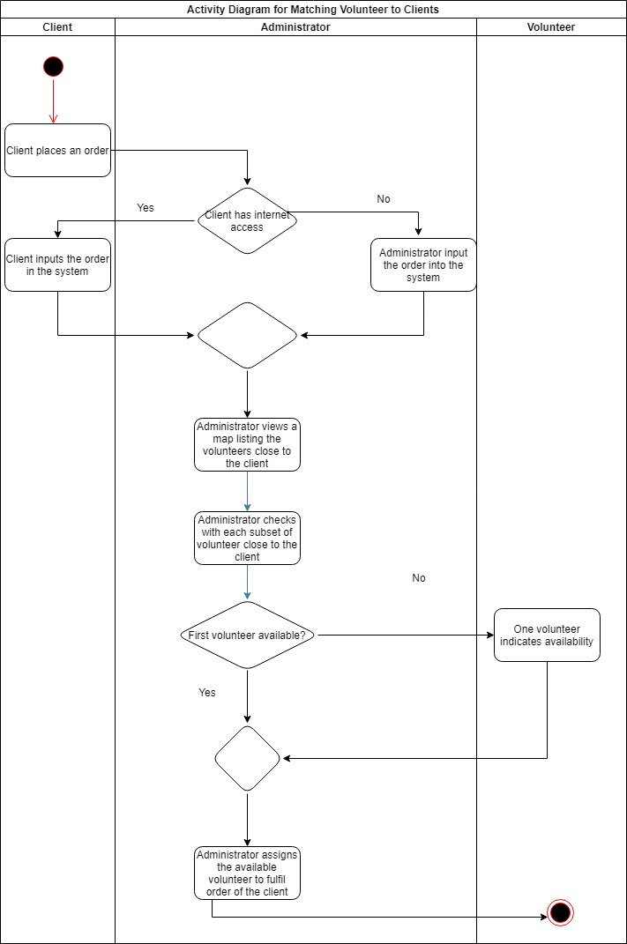

**Figure 2: An activity diagram showing how an administrator matches volunteers to a client in the proposed system**

**5.0 ASSESSMENT OF SYSTEM LIFECYCLE APPROACH, TOOLS, PROJECT TEAM, INFRASTRUCTURE FOR THE PROPOSED SYSTEM**

**5.1 Critical evaluation of the appropriate system lifecycle approach for developing the proposed system**

The measure of the success of any software system is its effectiveness in meeting the exact purpose of which it was intended (Nuseibeh, B., & Easterbrook, S. (2000, May)). The approach to providing the adequate software to meet the functional and non-functional requirements that where specified must be considered using various factors so we can have the right product. In the interview I deduced that the manager wants a system that will be simple to use by the administrators yet scalable to the increasing expansion that is ongoing in the charity organization.

I will be using the requirement engineering concepts by Jarke, M., & Lyytinen, K. (2015), these requirement features description helps to categorize the specified requirements and determine the appropriate approach.

**Table 5.0:** A table showing a summary of requirement descriptions

|  |  |
| --- | --- |
| **Requirement feature** | **Definition** |
| Volume | This is the extent to which the requirements influence the project |
| Veracity | This is a check of the consistency of the requirements with the needs of the business |
| Volatility | The rate the requirements change over a period |
| Vagueness | The understanding of the context and consequences of the requirement by both the stakeholders and the developers |
| Variance | The scope of the varying design |
| Velocity | The extent the requirements can change over time |

I will also be using a rating system that a specified below:

High (The requirements feature is greatly considered in the interviews) – 2

Low (The requirements feature is somewhat considered in the interviews) - 1

None (The requirements feature is not considered in the interviews) – 0

**Table 6.0:** A table showing the requirement engineering features recognition in the proposed system

|  |  |  |  |
| --- | --- | --- | --- |
| **Requirement features** | **Basic considerations** | **Level** | **Rate** |
| **Volume** | The size of the requirements of the proposed system is not so much. The expectations of the new system are limited to a few functional and non-functional requirements | Low | 1 |
| **Veracity** | The administrators currently have a way they carry out tasks, the new system has to achieve a great level of effectiveness. Veracity has to be considered so the proposed system matches the needs of the stakeholders | High | 2 |
| **Volatility** | The priority of the proposed system is to improve on the current system being used. The requirement will change over the period of time as the administrator starts using the new system | High | 2 |
| **Vagueness** | There is need to consider the understanding and consequence of implementing this new system, so the requirements are one that service the primary purpose of the organization | High | 2 |
| **Variance** | The variance is not a consideration at this stage | None | 0 |
| **Velocity** | The measure of the change in requirement over time is of much consideration as the business has a clearly defined business structure and new requirements for the system will emerge over time as the business expands | High | 2 |

From the table above we can see that the features such as Velocity, Volatility, Vagueness and Veracity are high priority according to the current specification for the new system. According to Zowghi, D., & Nurmuliani, N. (2002, December) in their study, the evolutionary complexity of a system often results from the ever-changing user requirements and the evolution of a software. The expansion of the business of the charity organization will experience an evolutionary change in user requirement has they take on more clients and expand to more zone, as specified by the manager. Therefore, the priority of the system lifecycle to be adopted should be one that accommodates such evolutionary changes in user requirement.

Having established that the high priority requirement features are volatility, velocity, the software methodology that will be used is the Agile methodology which is defined according to Srivastava, A., Bhardwaj, S., and S. Saraswat, S. (2017), “as a continuous iteration and testing which is employed in the software development lifecycle of a product”. The software development needs to be a continuous iteration which will involve the administrators and the software development team to ensure the proposed system achieves all requirements.

The type of agile methodology that will be used is the Scrum method. Scrum according to Srivastava, A., Bhardwaj, S., and S. Saraswat, S. (2017) “is the combination of iterative model and the incremental model. Scum was design for the following:

* It helps to increase the speed of development
* Align individual and organization’s motto
* Define a culture focusing on performance
* Support stakeholder value creation
* To have good communication of performance at all levels”

**5.2 Tools, team and infrastructure required to develop the proposed system**

**5.2.1 Project team**

The team needed for the development of the proposed project will be identified as one that can work according to the agile method of product development in transferring the knowledge and understanding of the requirements into actualization of a minimum viable product, also bringing adequate expertise and domain knowledge into the team. According to Joshi, K. D., Sarker, S., & Sarker, S. (2007), “to achieve effective knowledge transfer there should be:

* **Source capability: -** The amount of knowledge transferred by a source is positively related to the source’s capability
* **Source credibility: -** Credibility of the source refers to the extent to which a team member is perceived by other team members as trustworthy and reputable
* **Communication extent: -** The extent and frequency in which a team member communicates as perceived by the other team members.”

The scrum team needed is according to Mundra, A., Misra, S., & Dhawale, C. (2013) that stated the number of team member and structure in a scrum as:

* **Scrum Master:** Coordinates the scrum development processes
* **Product Owner:** The represent the stakeholders
* **Software developers:** Develops the software through writing codes
* **Software Testers:** Tests the software developed for bugs and drives improvements

**5.2.2 Tools and infrastructure needed**:

The following tools are the scrum tools used in the product development:

* **Product backlog:** This helps itemize the features to be developed and prioritizes them. This is used by the product owner.
* **Sprint:** This is a timebound period for a team to accomplish specific tasks towards developing a minimum viable product. Sprints usually take duration of 1 – 4 works
* **Sprint backlog:** This is a log of tasks to be done during a sprint
* **Daily Scrum:** This is a short daily meeting for each team member to discuss work done, what to be done and obstacles.
* Other tools used are Sprint burndown chart, Sprint Review

The software development will be done using XAML for the User interface and C# language. The IDE that will be used is Visual studio and GIT will be used for version control. Unit test will be used by the software tester to test the minimum viable product as well as the administrator will test manually.

* 1. **CONCLUSION**

We understand from the critical analysis of the current system that a spreadsheet means of storing data pose a huge risk to both the clients and the charity organization. We also discovered that the to build a minimum viable product according to the specification of the manager, an iterative approach needs to be used so the product because the velocity and volatility of the requirements are high priorities. The minimum viable product will be one that helps the administrator match clients to volunteer seamlessly eliminating the manual mean used in the current system. This will help for expansion and scalability.

**REFERENCE**

Jarke, M., & Lyytinen, K. (2015). “Complexity of Systems Evolution: Requirements Engineering Perspective”. *ACM Transactions on Management Information Systems (TMIS)*, *5*(3), 1-7.

Joshi, K. D., Sarker, S., & Sarker, S. (2007). Knowledge transfer within information systems development teams: Examining the role of knowledge source attributes. *Decision Support Systems*, *43*(2), 322-335.

Mundra, A., Misra, S., & Dhawale, C. (2013). "Practical Scrum-Scrum Team: Way to Produce Successful and Quality Software," 13th International Conference on Computational Science and Its Applications, 2013, pp. 119-123, doi: 10.1109/ICCSA.2013.25.

Nuseibeh, B., & Easterbrook, S. (2000, May). Requirement engineering: a roadmap. In *Proceedings of the Conference on the Future of Software Engineering* (pp. 35-46).

Srivastava, A., Bhardwaj, S., & S. Saraswat, S. (2017). "SCRUM model for agile methodology," 2017 International Conference on Computing, Communication and Automation (ICCCA), 2017, pp. 864-869, doi: 10.1109/CCAA.2017.8229928.

Zowghi, D., & Nurmuliani, N. (2002, December). A study of the impact of requirements volatility on software project performance. In *Ninth Asia-Pacific Software Engineering Conference, 2002.* (pp. 3-11). IEEE.